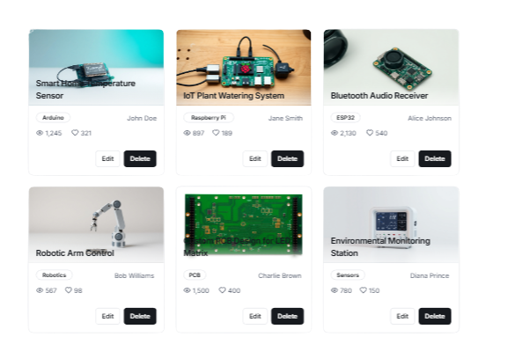
HOME ABOUT US CONTACT LOG IN
VVOOLLTTAARRAA
Log in
Username
Password Remember Me
Forgot Password?
Log in
Or Sign up
Dashboard
Projects
LOGOUT
VVoollttaarraa
My Projects Create
Log Out
HELLO, OLIVIA WILSON!

My Projects
ADMIN
Help & Support

Add notes or comments
Add notes or comments
Add notes or comments
Add notes or comments
Let's create a digital prototype to map out the user interface of our website.
Wireframe Builder (Website)

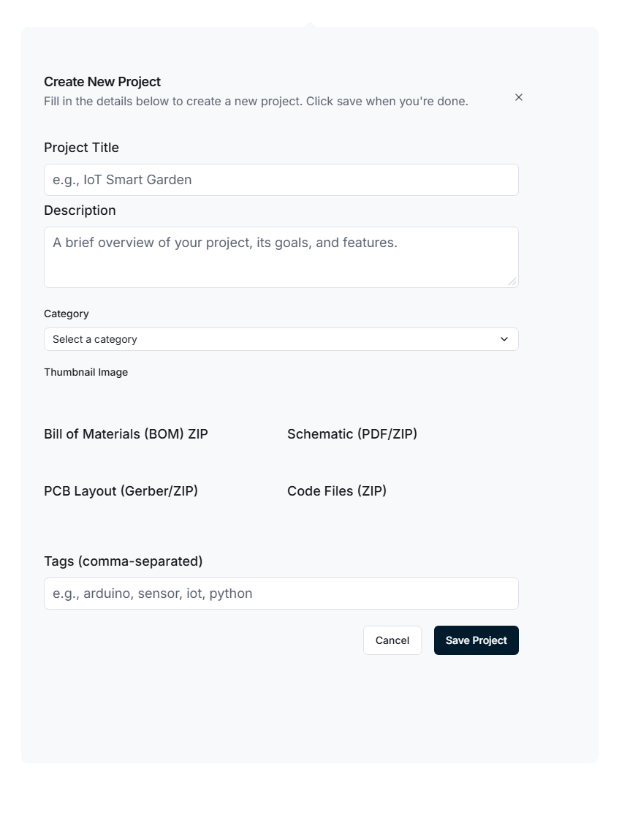
Landing Page 1
Creating project
Creator/Admin

